1TITLE: STUDY OF VARIOUS DEVELOPMENT BOARDS & PLATFORMS FOR IOT

Aim: To study the various development boards and IoT platforms used to implement IoT applications.

OBJECTIVE :

1. To understand working basic architecture and components of Internet of Things
2. To classify and compare the various development boards and platforms available for IoT Application.
3. To choose the development ecosystem to build the IoT application.

THEORY:

1. Introduction to Internet of Things

The Internet of Things (IoT) has a rich technological legacy and a bright future: ubiquitous connectivity has created a new paradigm, and the closed, static, and bounded systems of the past will soon be obsolete. With the connection of low-cost sensors to cloud platforms, it’s now possible to track, analyze, and respond to operational data at scale. The promise of the IoT is indeed wonderful: intelligent systems made up of smart machines that talk with each other and with people in real time, and data analytics driving optimization and transformation in industries as varied and far-reaching as aeronautics and agriculture, transportation and municipal services, manufacturing and healthcare, and even within our homes.

In 1999, Kevin Ashton of the Massachusetts Institute of Technology (MIT) coined the term Internet of Things. At the time, industrial automation technologies were starting to move from the factory into new environments like hospitals, banks, and offices. This early form of intercommunication often involved machines of the same type— such as a one ATM machine talking to another in the same general location—hence the term, Machine-to-Machine, or M2M.

As early M2M implementations grew increasingly more sophisticated, machines were connected

to other kinds of devices like servers. Those servers ultimately moved from on-premise locationsinto data centers and eventually “the cloud.” Today, the Internet of Things can include industrial and commercial products, everyday products like dishwashers and thermostats, and local networks of sensors to monitor farms and cities. In an IoT solution, objects can be sensed and controlled through the Internet, whether these objects are remote devices, smart products, or sensors that represent the status of a physical location. And information can be made available to applications, data warehouses, and business systems.

* 1. Definition of IoT

A dynamic global network infrastructure with self-configuring capabilities based on standard and

1

interoperable communication protocols where physical and virtual “things” have identities,physical attributes, and virtual personalities and use intelligent interfaces, and are seamlessly integrated into the information network, often communicate data.

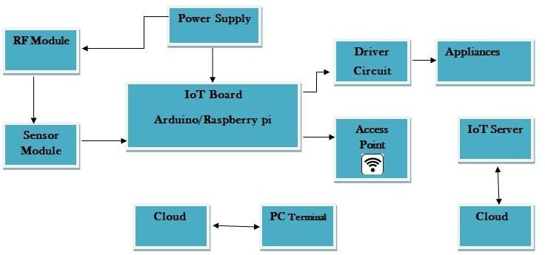

Block Diagram of Internet of Things (IoT) The Figure 1 shows the block diagram of Internet of Things (IoT) the IoT Board is the heart of the application where we can write the program and dump on it. The IoT Board may be either Arduino or Raspberry Pi depending upon the application. Arduino Suite can be use as a platform to dump the program (Phyton/C++) using I2C Communication Protocol or Serial Communication Protocol . The Sensor Module will measure the physical parameters and provides an output in terms of voltage which is given to an analog input of an Arduino/Raspberry board (A 0 to A 5 ). For Transmitting/Receiving the radio signals a RF module will be used. During the IoT application the configuration of a network is required. Virtual Private Server (VPS) is software defined, and can be easily configured. Most of the IoT Cloud servers like Amazon, Microsoft etc., they will use web based user interface in order to manage the server . The IoT Server can be used for monitoring and data gathering the information. The data received or transmitted through gateway server will be securely stored in Big Data Analytics.

1. Development Boards used for IoT
   1. Raspberry Pi

Raspberry Pi is undoubtedly the most popular platform used by many hobbyists and hackers. Even non-technical users depend on it for configuring their digital media systems and surveillance cameras. The recently launched Raspberry Pi 3 included built-in WiFi and Bluetooth making it the

most compact and standalone computer. Based on a Broadcom BCM2837 SoC with a 1.2 GHz 64- bit quad-core ARM Cortex-A53 processor and 1GB RAM, the Pi is a powerful platform. The Raspberry Pi 3 is equipped with 2.4 GHz WiFi 802.11n and Bluetooth 4.1 in addition to the 10/100 Ethernet port. The HDMI port makes it further easy to hook up A/V sources.

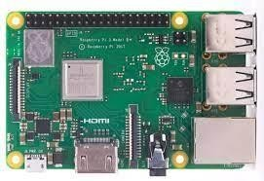

Raspberry Pi runs on a customized Debian Linux called Raspbian, which provides an excellent user experience. For developers and hackers, it offers a powerful environment to install a variety of packages including Node.js, the LAMP stack, Java, Python and much more. With four USB ports and 40 GPIO pins, you can connect many peripherals and accessories to the Pi. There are third party breakout boards to connect various Arduino shields to the Pi.

* 1. Intel Edison

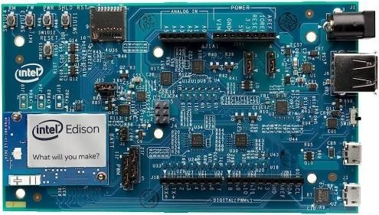Trust Intel to deliver the most powerful single-board computer for advanced IoT projects. Intel Edison is a high-performance, dual-core CPU with a single core micro-controller that can support complex data collection. It has an integrated Wi-Fi certified in 68 countries, Bluetooth 4.0 support, 1GB DDR and 4GB flash memory. Edison comes with two breakout boards – one that’s compatible with Arduino and the other board designed to be a smaller in size for easy prototyping. The Arduino breakout board has 20 digital input/output pins, including four pins as PWM outputs, Six analog inputs, one UART (Rx/Tx), and one I2C pin. Edison runs on a distribution of embedded Linux called Yocto. It’s one of the few boards to get certified by Microsoft, AWS, and IBM for cloud connectivity.

* 1. Arduino Uno

Arduino Uno remains to be the top favorite of absolute beginners and experts. Considered to be one of the first microcontroller-based development boards, the Arduino Uno R3 is simplest yet the most powerful prototyping environment. It is based on the ATmega328P which has 14 digital input/output pins and six analog inputs. Though it comes with just 32 KB of Flash memory, it can accommodate code that deals with complex logic and operations.

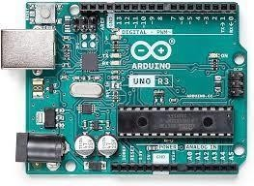

Arduino enjoys the best community participation and support. From sensors to actuators to libraries, it has a thriving ecosystem. The board layout has become almost the gold standard for microcontrollers. Almost every prototyping environment tries to be compatible with the Arduino pin breakout. The open source IDE to develop sketches is another reason for its popularity. With a simple syntax based on ‘C’ language, the code is easy to learn. If you are eager to learn basics of electronics and IoT, look no further. Do yourself a favor and get an Arduino Uno R3.

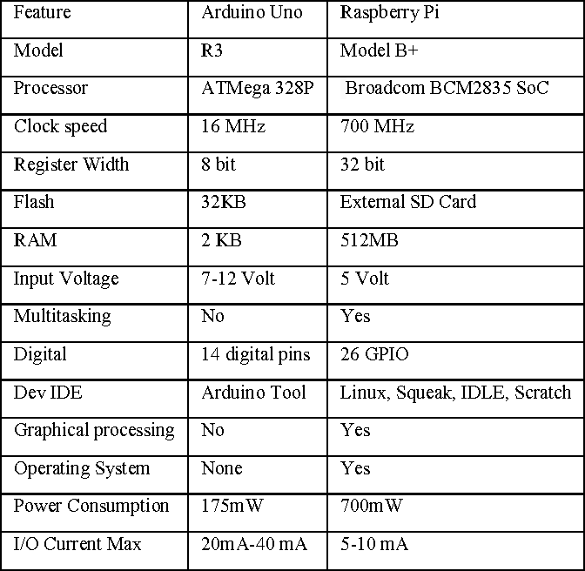

* 1. ESP32

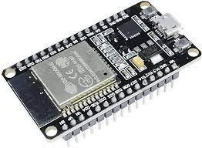ESP32 is a series of low-cost, low-power system on a chip microcontrollers with integrated Wi-Fi and dual-mode Bluetooth. The ESP32 series employs either a Tensilica Xtensa LX6 microprocessor in both dual-core and single-core variations, Xtensa LX7 dual-core microprocessor or a single-core RISC-V microprocessor and includes built-in antenna switches, RF balun, power amplifier, low- noise receive amplifier, filters, and power-management modules. ESP32 is created and developed by Espressif Systems, a Shanghai-based Chinese company, and is manufactured by TSMC using their 40 nm process. It is a successor to the ESP8266 microcontroller.

* 1. ESP8266

ESP826 is an inexpensive Wi-Fi microchip that is featured with TCP/IP stack and micro-controller using UART. It has 1 MiB of built-in flash that allows the single-chip devices capable of connecting to Wi-Fi. Each module is pre-programmed with AT commands that makes it a plug-n-play model for developing IoT projects. ESP8266 also provides WEP(wired equivalent privacy) or WPA/WPA2 authentication for secure network connection. The module also has 16 GPIO(General-purpose input/output (GPIO) pins that can be used for defining specific purposes.

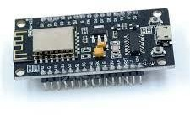

* 1. NodeMCU

An open-source firmware and development kit that helps you to prototype your IOT product within a few Lua script lines. It includes firmware which runs on the ESP8266 Wi-Fi SoC from Espressif Systems, and hardware which is based on the ESP-12 module. The term "NodeMCU" by default refers to the firmware rather than the development kits. The firmware uses the Lua scripting language. It is based on the eLua project, and built on the Espressif Non-OS SDK for ESP8266. It uses many open source projects, such as lua-cjson, and spiffs.

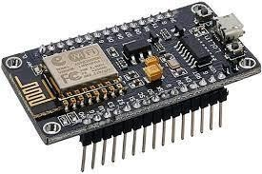

* 1. Beagle Bone Black

Beagle Board is a cost-efficient platform for developers and learners of IoT projects. It works on Linux and has ARM Cortex A8 processor that boots in under 10 seconds. The board has built-in Ethernet for network connectivity along with features like USB and HDMI ports to display and other connectivity. Additionally, the BeagleBone Black has a vast community that provides various learning guides, videos and projects that will help to build and learn your IoT solutions.

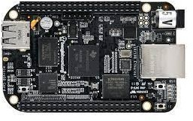

* 1. Arduino YUN

The Arduino Yún is an Arduino board unlike any other. While programming it is very similar to the Arduino Leonardo and uses the same processor, the Atmel ATmega32U4, it also has an additional processor, an Atheros AR9331, running Linux and the OpenWrt wireless stack. Programming the 32U4 via USB is identical to the Arduino Leonardo. The board has built-in Ethernet and WiFi support, a USB-A port, microSD card slot, 20 digital input/output pins (of which 7 can be used as PWM outputs and 12 as analog inputs), a 16 MHz crystal oscillator, a micro USB connection, an ICSP header, and a 3 reset buttons.

IoT Platforms

The internet of things is a simple mechanism of embedding sensors, chips and tags in consumer devices, heavy machines, remote assets and vehicles, that establishes an internet-enabled connection and remotely transmits data to the provider. A true end-to-end IoT Platform is a software framework that remotely connects all 'things', manages devices, collects data, allows action management, analytics and visualization and integrates with cloud services.

1. Amazon Web Services

The cloud services provided by Amazon include an IoT suite that supports all aspects of Internet-

of-Things applications:

AWS IoT Core, which is the base on which any IoT application can be built. Via AWS IoT Core, devices can connect to the Internet and to each other and exchange data. Billions of messages can be sent between the devices and cloud storage over a secure connection. The platform supports various communication protocols, including custom ones, thus enabling communication between devices from different manufacturers.AWS IoT Device Management allows easy addition and organization of devices. The service ensures secure and scalable performance with the possibilities of monitoring, troubleshooting and updating the device functionality.AWS IoT Analytics, providing a service for automated analytics of large amounts of various IoT data, including unstructured data from different types of devices. The data gathered and processed by the service is ready for use in machine learning. AWS IoT Device Defender, supporting the configuration of security mechanisms for the IoT systems. AWS IoT Device Defender enables the setup and management of security policies controlling device authentication and authorization, as well as providing encryption mechanisms.

1. Google Cloud IoT

Google Cloud Platform is another global cloud provider that supports IoT solutions. Its Google Cloud IoT package allows you to build and manage IoT systems of any size and complexity. The Google Cloud IoT solution includes a number of services that enable the creation of IoT networks:

* + Cloud IoT Core, the heart of the Google Cloud IoT suite, that allows connecting various devices and gathers their data.
  + Cloud Pub/Sub, the service which processes event data and provides real-time stream analytics.
  + Cloud Machine Learning Engine, allowing the building of ML models and use of the data received from IoT devices.

1. Microsoft Azure IoT Suite

Microsoft Azure, a cloud service giant in the same league with AWS and Google Cloud Platform. Microsoft Azure IoT Suite offers both preconfigured solutions and the possibility to customize them and create new ones according to the project requirements. With Microsoft Azure IoT Suite, you are getting the strongest security mechanisms, superb scalability, and easy integration with any existing or future systems. The platform allows you to connect hundreds of devices by various manufacturers, gather data analytics and use the IoT data for machine learning purposes.

1. IBM Watson Internet of Things

The IBM platform supports effective remote device control, secure data transmission and storage in cloud, real-time data exchange, as well as machine learning options thanks to the integration with AI technology.The development platform offered by IBM includes a number of convenient tools and services, making IoT software creation easier and more efficient.

1. ThingSpeak

ThingSpeak is an application platform for the development of IoT systems. It can help you to build the application which works upon the data collected by sensors. ThingSpeak is an open data platform for IoT application development. ThingSpeak is the perfect complement to an existing enterprise system to tap into the Internet of Things. It provides the ability to integrate your data

with a variety of third-party platforms, systems and technologies, including other leading IoT platforms such as ioBridge and Arduino. ThingSpeak platform provides following functionality to support IoT system: 1) Collect: Sends sensor and device data collected from it to the cloud so that the data can be further analysed. 2) Analyse: ThingSpeak can analyse the data received from sensors or devices and can derive the virtual representation of the data. 3) Act: Based upon the analysis, it will trigger the action to enable functioning of IoT system and application.

Key features:

* + It provides real time collection of data storage
  + Data analytics and Visualization using MATLAB
  + Device Communication
  + Open API support
  + Provides Geolocation data
  + Facilitates plugins

Conclusion: